SEC Form 3
FORM 3 | UNITED STATES SECURITIES AND EXCHANGE COMMISSION  Washington, D.C. 20549  INITIAL STATEMENT OF BENEFICIAL OWNERSHIP OF SECURITIES  Filed pursuant to Section 16(a) of the Securities Exchange Act of 1934  or Section 30(h) of the Investment Company Act of 1940
  OMB APPROVAL
  OMB Number: | 3235-0104
  Estimated average burden
  hours per response: | 0.5
1. Name and Address of Reporting Person*  (Street) | 2. Date of Event Requiring Statement (Month/Day/Year)  09/03/2026 | 3. Issuer Name and Ticker or Trading Symbol  Brighthouse Financial, Inc. [ BHF ]  Foreign Trading Symbol
  Cook Richard A.
  (Last) | (First) | (Middle)
  11225 NORTH COMMUNITY HOUSE ROAD
  CHARLOTTE | NC | 28277
  (City) | (State) | (Zip)
 |  | 4. Relationship of Reporting Person(s) to Issuer  (Check all applicable) | 5. If Amendment, Date of Original Filed (Month/Day/Year)
   | Director |  | 10% Owner
   | Officer (give title below) |  | Other (specify below)
  Chief Accounting Officer
6. Individual or Joint/Group Filing (Check Applicable Line)
Form filed by One Reporting Person
Form filed by More than One Reporting Person

Table I - Non-Derivative Securities Beneficially Owned
1. Title of Security (Instr. 4) | 2. Amount of Securities Beneficially Owned (Instr. 4) | 3. Ownership Form: Direct (D) or Indirect (I) (Instr. 5) | 4. Nature of Indirect Beneficial Ownership (Instr. 5)
Common Stock | 6,914 | D
Common Stock | 55 | I | Shares held by spouse
Table II - Derivative Securities Beneficially Owned
(e.g., puts, calls, warrants, options, convertible securities)
1. Title of Derivative Security (Instr. 4) | 2. Date Exercisable and Expiration Date (Month/Day/Year) |  | 3. Title and Amount of Securities Underlying Derivative Security (Instr. 4) |  | 4. Conversion or Exercise Price of Derivative Security | 5. Ownership Form: Direct (D) or Indirect (I) (Instr. 5) | 6. Nature of Indirect Beneficial Ownership (Instr. 5)
1. Title of Derivative Security (Instr. 4) | Date Exercisable | Expiration Date | Title | Amount or Number of Shares | 4. Conversion or Exercise Price of Derivative Security | 5. Ownership Form: Direct (D) or Indirect (I) (Instr. 5) | 6. Nature of Indirect Beneficial Ownership (Instr. 5)
Restricted Stock Units | (1) | (1) | Common Stock | 1,650 | (2) | D
Restricted Stock Units | (3) | (3) | Common Stock | 758 | (2) | D
Restricted Stock Units | (4) | (4) | Common Stock | 337 | (2) | D
Explanation of Responses:
1. Restricted Stock Units ("RSUs") awarded in 2026, which will vest in three equal installments on the first business day in March 2027, 2028 and 2029.
2. Each RSU represents the contingent right to receive one share of Brighthouse Financial, Inc. common stock.
3. Represents unvested portion of RSUs awarded in 2025, which will vest in two equal installments on the first business day in March 2027 and 2028.
4. Represents unvested portion of RSUs awarded in 2024, which will vest on the first business day in March 2027.
Remarks:
Exhibit List - Exhibit 24 - Power of Attorney
 | /s/ Alexander V. Ulianov, Attorney-in-Fact, on behalf of Richard A. Cook | 09/03/2026
 | ** Signature of Reporting Person | Date
Reminder: Report on a separate line for each class of securities beneficially owned directly or indirectly.
* If the form is filed by more than one reporting person, see Instruction 5 (b)(v).
** Intentional misstatements or omissions of facts constitute Federal Criminal Violations See 18 U.S.C. 1001 and 15 U.S.C. 78ff(a).
Note: File three copies of this Form, one of which must be manually signed. If space is insufficient, see Instruction 6 for procedure.
Persons who respond to the collection of information contained in this form are not required to respond unless the form displays a currently valid OMB Number.
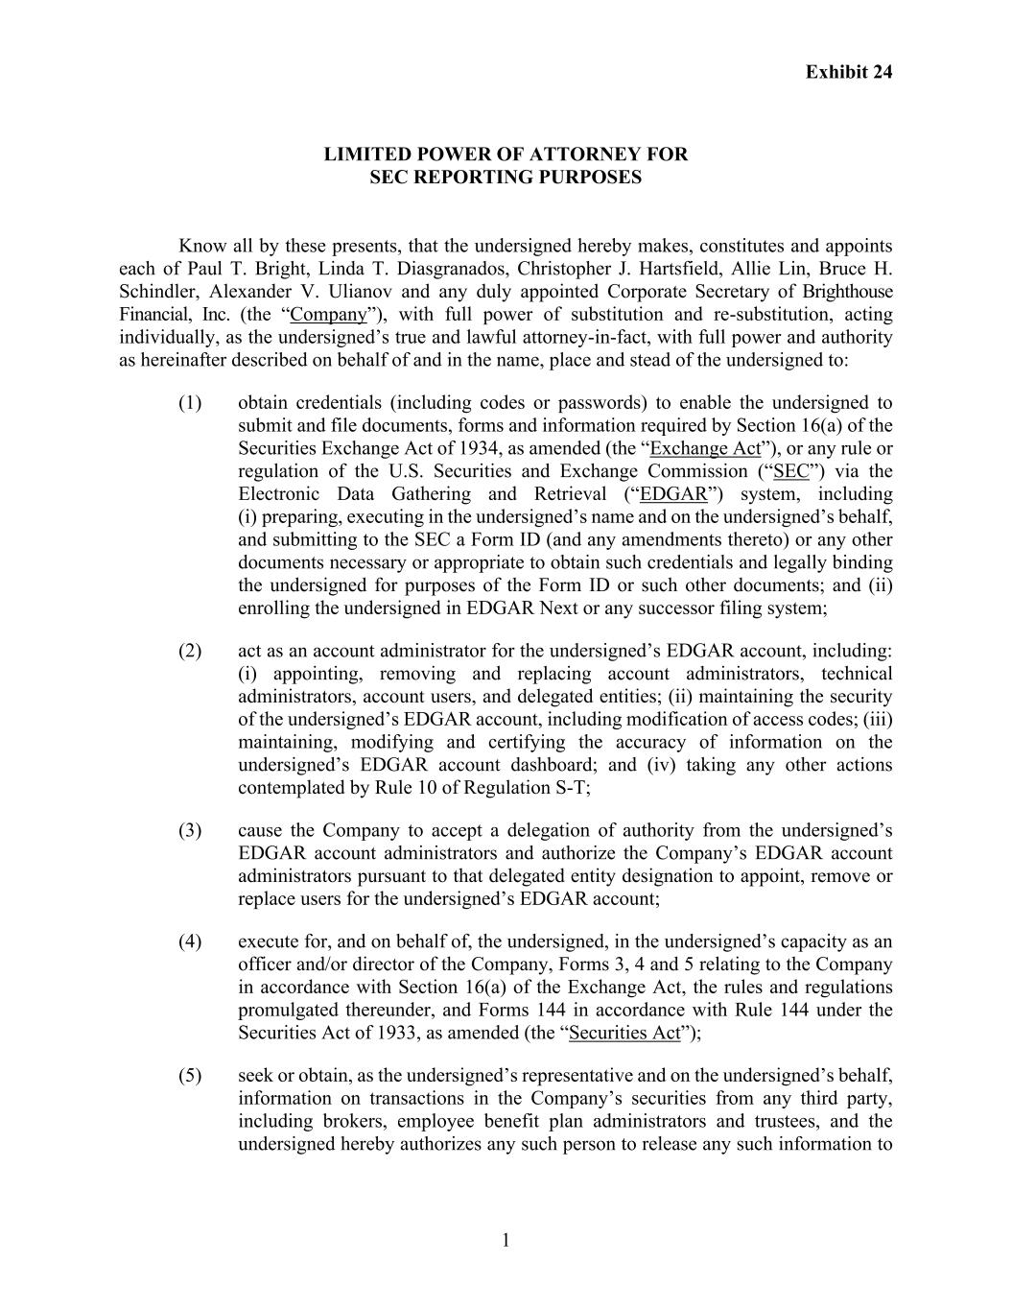
Exhibit 24 1 LIMITED POWER OF ATTORNEY FOR SEC REPORTING PURPOSES Know all by these presents, that the undersigned hereby makes, constitutes and appoints each of Paul T. Bright, Linda T. Diasgranados, Christopher J. Hartsfield, Allie Lin, Bruce H. Schindler, Alexander V. Ulianov and any duly appointed Corporate Secretary of Brighthouse Financial, Inc. (the “Company”), with full power of substitution and re-substitution, acting individually, as the undersigned’s true and lawful attorney-in-fact, with full power and authority as hereinafter described on behalf of and in the name, place and stead of the undersigned to: (1) obtain credentials (including codes or passwords) to enable the undersigned to submit and file documents, forms and information required by Section 16(a) of the Securities Exchange Act of 1934, as amended (the “Exchange Act”), or any rule or regulation of the U.S. Securities and Exchange Commission (“SEC”) via the Electronic Data Gathering and Retrieval (“EDGAR”) system, including (i) preparing, executing in the undersigned’s name and on the undersigned’s behalf, and submitting to the SEC a Form ID (and any amendments thereto) or any other documents necessary or appropriate to obtain such credentials and legally binding the undersigned for purposes of the Form ID or such other documents; and (ii) enrolling the undersigned in EDGAR Next or any successor filing system; (2) act as an account administrator for the undersigned’s EDGAR account, including: (i) appointing, removing and replacing account administrators, technical administrators, account users, and delegated entities; (ii) maintaining the security of the undersigned’s EDGAR account, including modification of access codes; (iii) maintaining, modifying and certifying the accuracy of information on the undersigned’s EDGAR account dashboard; and (iv) taking any other actions contemplated by Rule 10 of Regulation S-T; (3) cause the Company to accept a delegation of authority from the undersigned’s EDGAR account administrators and authorize the Company’s EDGAR account administrators pursuant to that delegated entity designation to appoint, remove or replace users for the undersigned’s EDGAR account; (4) execute for, and on behalf of, the undersigned, in the undersigned’s capacity as an officer and/or director of the Company, Forms 3, 4 and 5 relating to the Company in accordance with Section 16(a) of the Exchange Act, the rules and regulations promulgated thereunder, and Forms 144 in accordance with Rule 144 under the Securities Act of 1933, as amended (the “Securities Act”); (5) seek or obtain, as the undersigned’s representative and on the undersigned’s behalf, information on transactions in the Company’s securities from any third party, including brokers, employee benefit plan administrators and trustees, and the undersigned hereby authorizes any such person to release any such information to

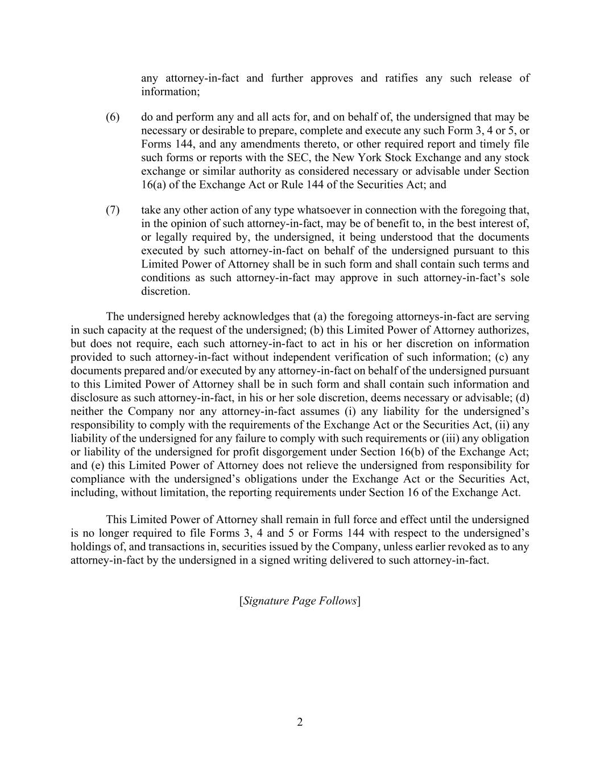
2 any attorney-in-fact and further approves and ratifies any such release of information; (6) do and perform any and all acts for, and on behalf of, the undersigned that may be necessary or desirable to prepare, complete and execute any such Form 3, 4 or 5, or Forms 144, and any amendments thereto, or other required report and timely file such forms or reports with the SEC, the New York Stock Exchange and any stock exchange or similar authority as considered necessary or advisable under Section 16(a) of the Exchange Act or Rule 144 of the Securities Act; and (7) take any other action of any type whatsoever in connection with the foregoing that, in the opinion of such attorney-in-fact, may be of benefit to, in the best interest of, or legally required by, the undersigned, it being understood that the documents executed by such attorney-in-fact on behalf of the undersigned pursuant to this Limited Power of Attorney shall be in such form and shall contain such terms and conditions as such attorney-in-fact may approve in such attorney-in-fact’s sole discretion. The undersigned hereby acknowledges that (a) the foregoing attorneys-in-fact are serving in such capacity at the request of the undersigned; (b) this Limited Power of Attorney authorizes, but does not require, each such attorney-in-fact to act in his or her discretion on information provided to such attorney-in-fact without independent verification of such information; (c) any documents prepared and/or executed by any attorney-in-fact on behalf of the undersigned pursuant to this Limited Power of Attorney shall be in such form and shall contain such information and disclosure as such attorney-in-fact, in his or her sole discretion, deems necessary or advisable; (d) neither the Company nor any attorney-in-fact assumes (i) any liability for the undersigned’s responsibility to comply with the requirements of the Exchange Act or the Securities Act, (ii) any liability of the undersigned for any failure to comply with such requirements or (iii) any obligation or liability of the undersigned for profit disgorgement under Section 16(b) of the Exchange Act; and (e) this Limited Power of Attorney does not relieve the undersigned from responsibility for compliance with the undersigned’s obligations under the Exchange Act or the Securities Act, including, without limitation, the reporting requirements under Section 16 of the Exchange Act. This Limited Power of Attorney shall remain in full force and effect until the undersigned is no longer required to file Forms 3, 4 and 5 or Forms 144 with respect to the undersigned’s holdings of, and transactions in, securities issued by the Company, unless earlier revoked as to any attorney-in-fact by the undersigned in a signed writing delivered to such attorney-in-fact. [Signature Page Follows]

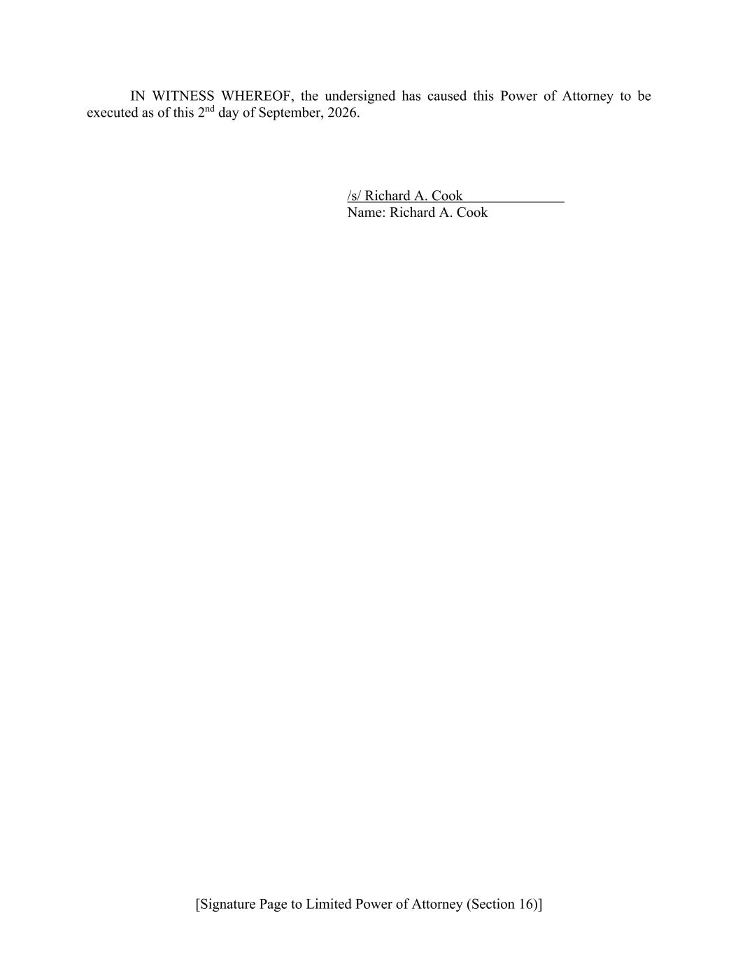
[Signature Page to Limited Power of Attorney (Section 16)] IN WITNESS WHEREOF, the undersigned has caused this Power of Attorney to be executed as of this 2nd day of September, 2026. /s/ Richard A. Cook Name: Richard A. Cook

